Instillation manual

Joomla 5.0.2

Dimah Mehdawi

Software Development and Documentation



Contents

Introduction 3

Joomla overview 3

Purpose of installation manual 3

Target audience and prerequisites 3

System Requirements 3

Server Requirements: 3

Software Requirements: 3

System Requirements cont. 4

Additional Considerations: 4

Deployment Diagram 4

Installation Procedure 5

WAMP installation 5

WAMP installation cont. 6

WAMP installation cont. 7

Testing WAMP server 8

Installing Joomla 8

How to install Joomla? 8

Installing Joomla Cont. 10

Test Joomla is working 11

Configuration Settings 11

Configuration Settings cont. 12

Success and Finishing Up the Installation 13

Testing and Verification 14

Technical Support and Contact Information 15

FAQ 15

General Joomla Support: 15

More help 15

# Introduction

## Joomla overview

Joomla is a content management system is software that keeps track of every piece of content on your Web site, much like your local public library keeps track of books and stores them. Content can be simple text, photos, music, video, documents, or just about anything you can think of. A major advantage of using a CMS is that it requires almost no technical skill or knowledge to manage. The CMS manages all your content, so you don't have to. CMS also helps you track your content easily and help you develop and manage your content in the best possible way.

## Purpose of installation manual

Purpose is to guide users through the process of installing Joomla, from acquiring the software to launching the website. And to ensure a smooth and successful installation process, regardless of the user's technical expertise. And to familiarize users with the basic Joomla administration interface and essential configuration options.

## Target audience and prerequisites

Joomla! is designed to be easy to install and set up even if you're not an advanced user. Many Web hosting services offer a single-click install or auto installers, getting your new site up and running in just a few minutes. Since Joomla is so easy to use, as a Web designer or Developer, you can quickly build sites for your clients. Then, with a minimal amount of instruction, you can empower your clients to easily manage their own sites themselves.

# System Requirements

## Server Requirements:

* Web Hosting: Choose a web hosting provider that supports PHP and MySQL. In this instillation manual we will use WAMP server to lunch Joomla and we will demonstrate how to install it too.

WAMP stands for Windows, Apache, MySQL, and PHP. It's a software stack or package that creates a virtual server environment on your Windows computer.

## Software Requirements:

* Web Browser: Any modern web browser like Chrome, Firefox, or Safari should work.
* Archive Utility: An archive utility like WinRAR or 7-Zip is necessary to extract the downloaded Joomla! package file.

# System Requirements cont.

## Additional Considerations:

* **Security**: Ensure your chosen web hosting provider prioritizes security and offers regular updates. Consider SSL certificates for secure communication between your website and visitors.
* **Performance**: Choose a hosting plan with adequate resources (RAM, CPU, storage) to handle your website's traffic and functionality effectively.
* **Knowledge Level**: While Joomla! aims to be user-friendly, basic familiarity with website concepts and technology can be helpful during installation and configuration.

## Deployment Diagram

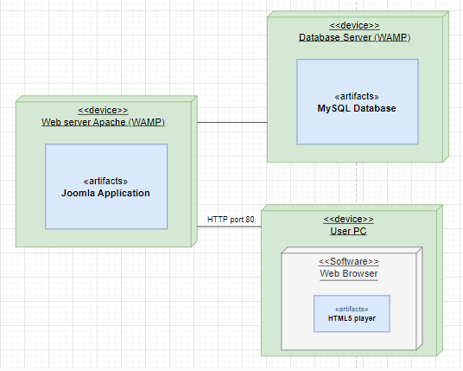

# Installation Procedure

## WAMP installation

* Visit [**https://www.wampserver.com/en/**](https://www.wampserver.com/en/)
* Based on your system specification download the latest version of WampServer.

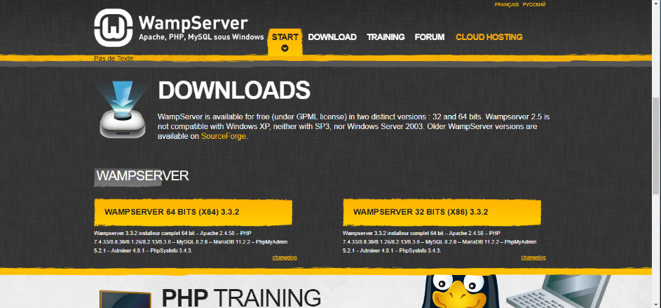

* One the Download is complete run the installer by double-clicking on the downloaded file.

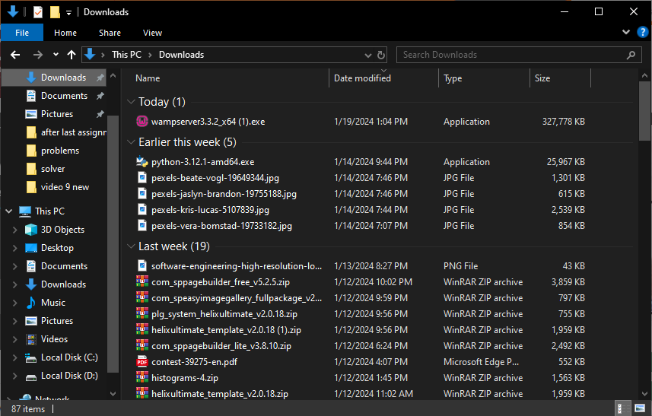

## WAMP installation cont.

* Select your preferred language for the installation process and click "OK."

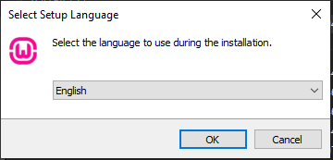

* Read the license agreement, and if you agree, select "I accept the agreement" and click "Next."

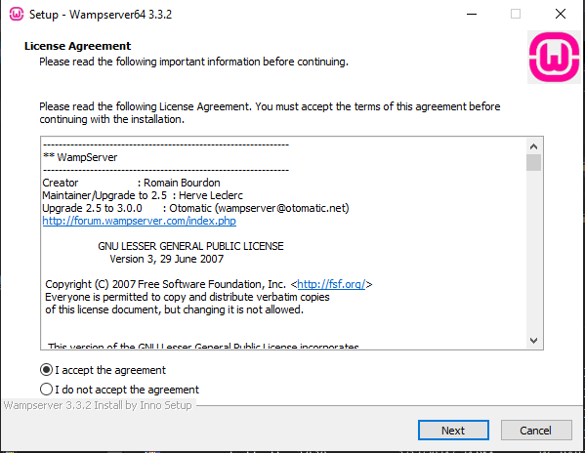

* Ensure that Visual C++ Packages are installed on you device, In case that they are not installed:

1. Go to [**Wampserver - Files and addons (aviatechno.net)**](https://wampserver.aviatechno.net/)**.**

2. Scroll down to that Visual C++ Packages.

3. Download and run all the missed packages.

4.Once all downloads are completed restart your device and run WAMP installer again.

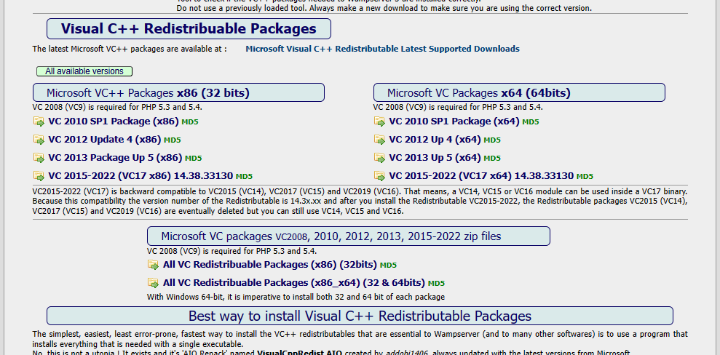

## WAMP installation cont.

* Choose the destination folder where you want to install WampServer. The default location is usually fine for most users. Click "Next" to proceed.

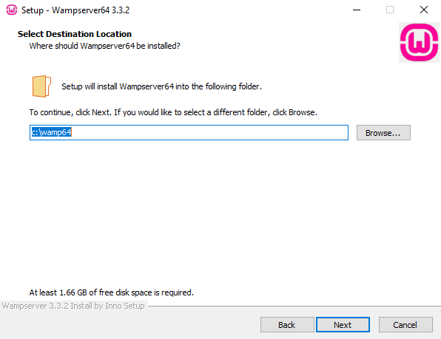

* The installer will copy files and set up the necessary components. This may take a few minutes.
* Click "Finish" to complete the installation.
* After installation, launch WampServer. You should see a WampServer icon in your system tray (near the clock) and on your desktop.
* Double click on it to start the server.
* It will be green if everything is working correctly.

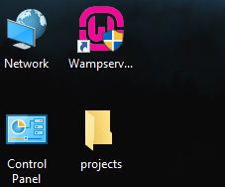

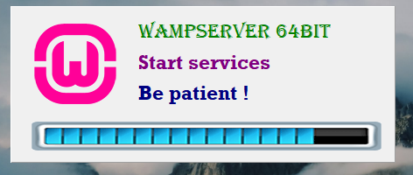



## Testing WAMP server

Open your web browser and navigate to **http://localhost/.** You should see the WampServer homepage, indicating a successful installation.

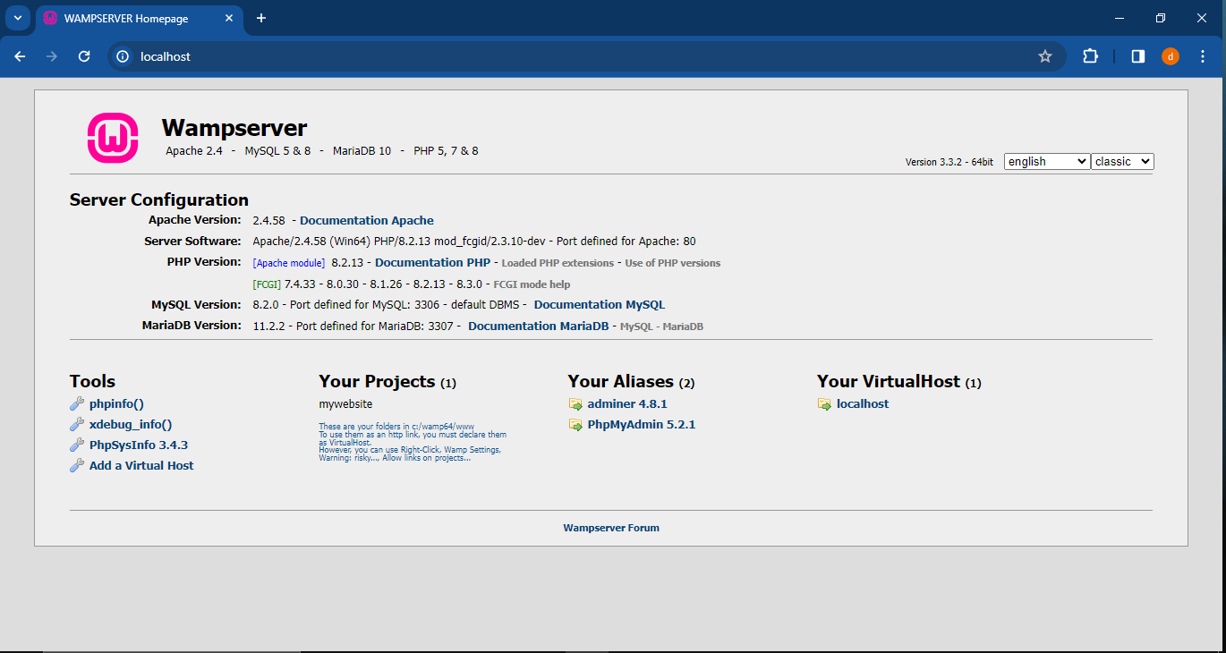

Now, you have WampServer installed on your Windows system, and you can use it for local web development. You can place your web project files in the "www" directory within the WampServer installation directory to start building and testing your websites.

# Installing Joomla

## How to install Joomla?

1. Go to [**https://downloads.joomla.org/**](https://downloads.joomla.org/)

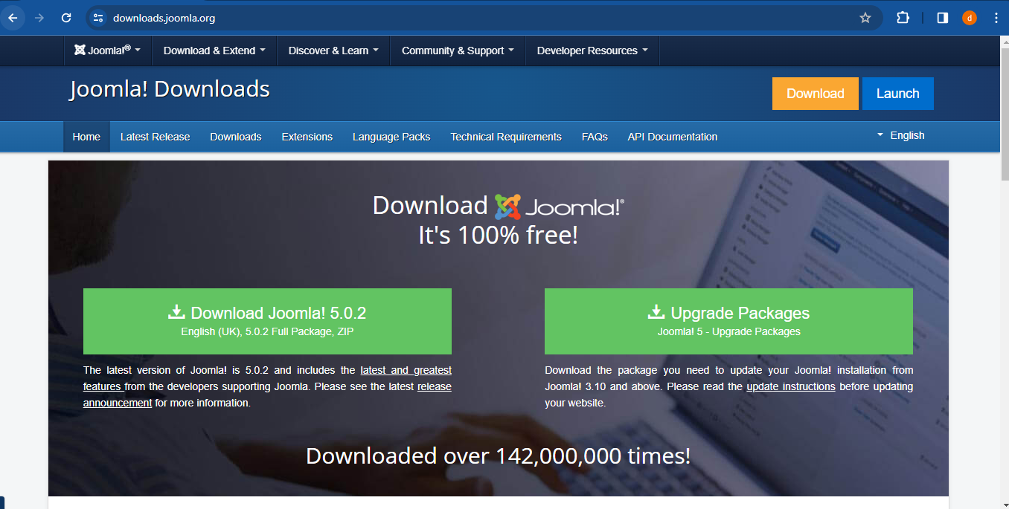

1. Click on Download Joomla.
2. Once the Joomla full package is downloaded copy the file.

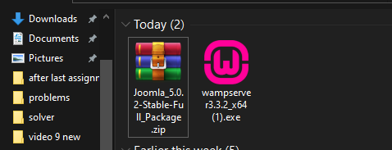

1. Navigate to where the wamp64 folder exist (usually on local disk C) and open it.

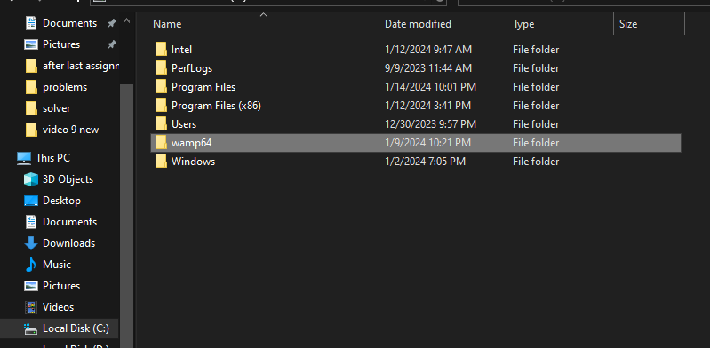

1. Enter the “www” folder.

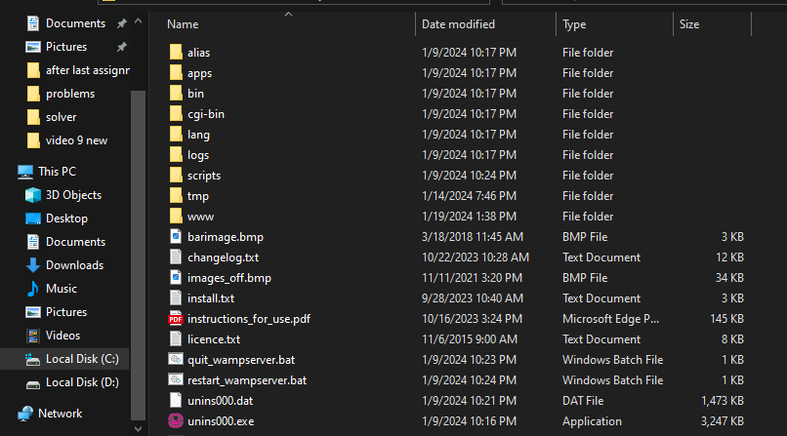

# Installing Joomla Cont.

1. Create a folder of your project and name it as you like for example “my website”

and enter insider it.

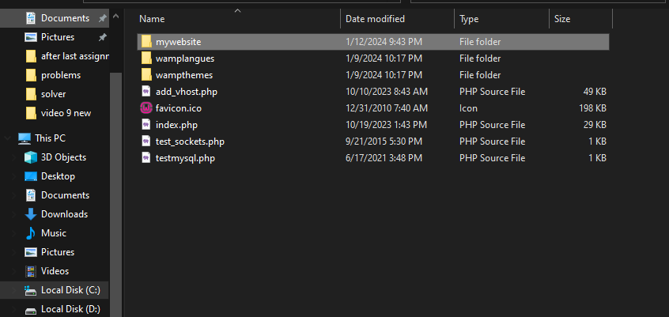

1. Place the copied Joomla folder inside the folder you created and extract the Joomla folder.

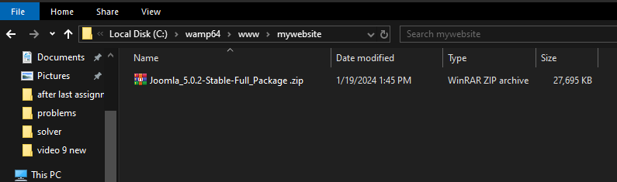

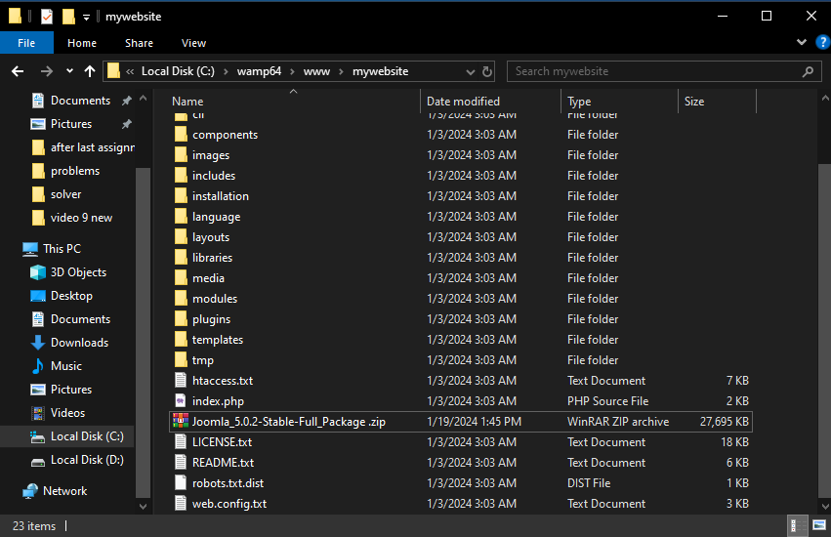

## Test Joomla is working

* Make sure that WAMP server is working
* On your web browser search bar, Write localhost/”your folder name”, in our case **localhost/mywebsite**

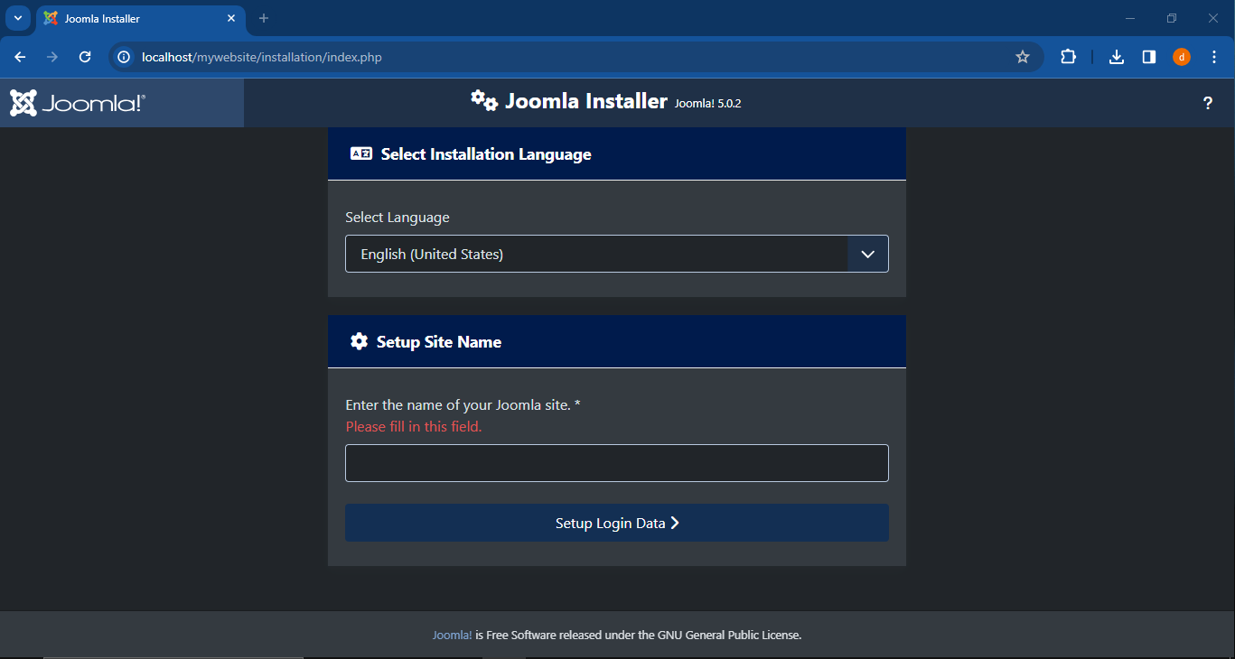

# Configuration Settings

Fill in the following information:

* **Site Name**: the name of your website — this can be changed at any point later in the Site Global Configuration page.

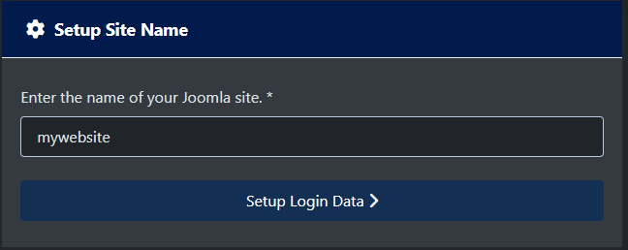

* **Admin Real name.**
* **Admin Username.**
* **Admin Email Address**: the admin email address. Enter a valid email in case you forget your password. This is the email address where you'll receive a link to change the admin password.
* **Admin Password.**

# Configuration Settings cont.

* After filling you information press setup database connection

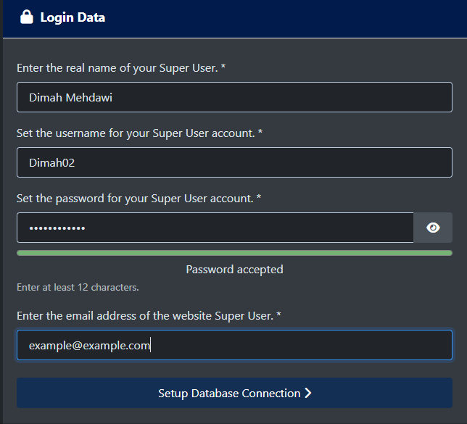

* **Database Type:** choose mysqli which is coming in wamp
* **Hostname** where is your database located? Common is *localhost*
* **Username:** the username used to connect to the database which is root
* **Password:** leave it blank
* Leave all other fields as is.
* Press install Joomla

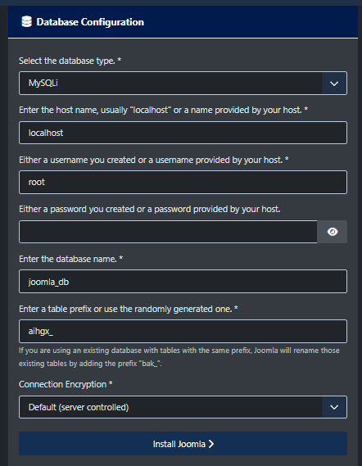

## Success and Finishing Up the Installation

Congratulations! Joomla! 5 is now installed.

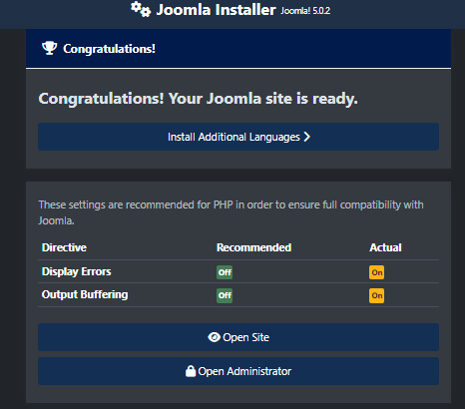

There is one last step to complete the installation. **You must delete the Installation Folder**. Click on Remove Installation folder and a success message will appear. Now you can navigate to the Administrator. Log in by clicking Administrator or go right to your site by clicking Site.

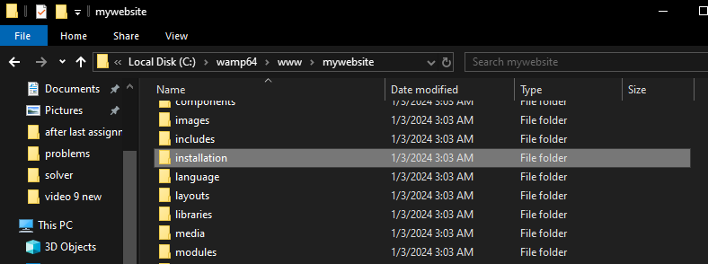

# Testing and Verification

To ensure that your Joomla project is working correctly:

1. Open your web browser and enter [**http://localhost/mywebsite/**](http://localhost/mywebsite/)to view your website page.
2. To reach you administration page and start editing your website page enter [**http://localhost/mywebsite/administrator/**](http://localhost/mywebsite/administrator/)

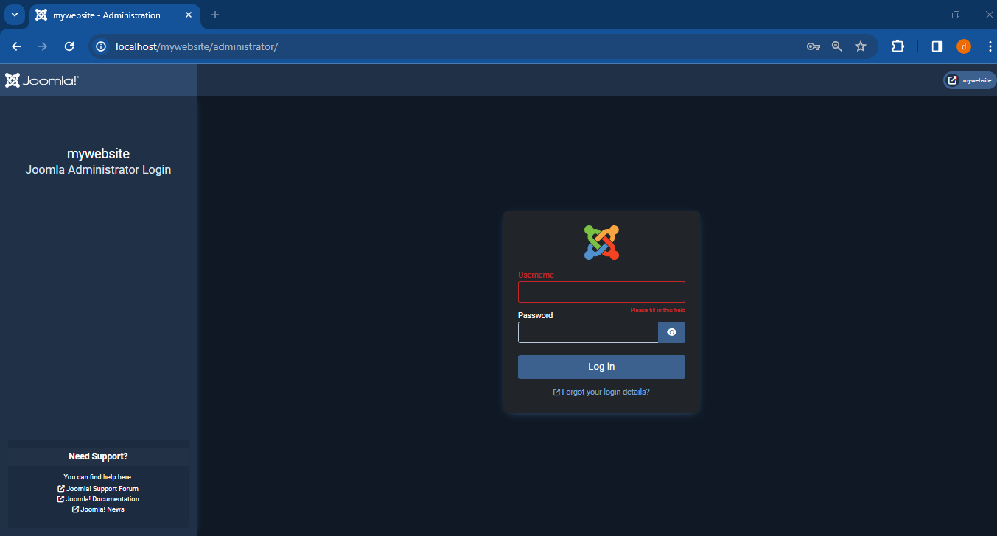

1. Enter your username and password to view the administrator page

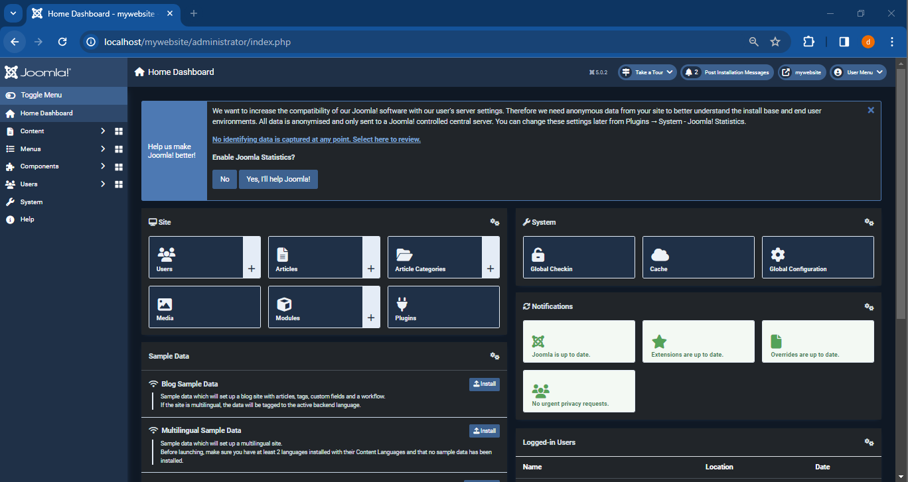

# Technical Support and Contact Information

Visit Joomla official website for more information

[**https://www.joomla.org/**](https://www.joomla.org/)

## FAQ

* Make sure to read all frequently asked question if any issue occurred

[**https://docs.joomla.org/Category:FAQ**](https://docs.joomla.org/Category:FAQ)

## General Joomla Support:

1. Joomla! Forum: This is a forum run by the Joomla! community, where you can ask questions and get help from experienced Joomla users and developers. It's a great resource for general questions about Joomla, troubleshooting, and finding tutorials.

**https://www.joomdev.com/5-best-forum-joomla-extensions/**

1. Joomla! Documentation: The official Joomla! documentation is a comprehensive resource for learning about Joomla and finding answers to common questions. It's a good starting point before hitting the forum or other support channels.

**https://magazine.joomla.org/all-issues/october/joomla-documentation-a-joomla-solution**

1. Mailing lists: Joomla! offers various mailing lists for specific topics like security, development, and extensions. Joining the relevant mailing list can be a good way to receive updates and connect with other users working on similar issues.

[**https://www.phoca.cz/news/1296-phoca-email-version-5-0-0-released-joomla-5**](https://www.phoca.cz/news/1296-phoca-email-version-5-0-0-released-joomla-5)

## More help

Visit **https://www.mediawiki.org/wiki/Help:Contents**